EcoTrace Supply Chain Verifier

EcoTrace Supply Chain Verifier is a web-based traceability platform designed to increase transparency in product supply chains and promote responsible consumption. The platform enables manufacturers and supply chain partners to record each stage of a product’s journey from production to final delivery creating a verifiable history of the product lifecycle. Consumers can access this information by scanning a product code, allowing them to understand how and where the product was produced, transported, and handled. By improving visibility into supply chain practices, EcoTrace supports ethical sourcing, sustainability, and accountability in line with Sustainable Development Goal 12 – Responsible Consumption and Production.

Problem Statement
Consumers today have limited visibility into how the products they purchase are sourced, manufactured, and transported. Important information such as the origin of raw materials, ethical labour practices, and the environmental impact of production and logistics is often not accessible or clearly communicated. This lack of transparency makes it difficult for consumers to make informed purchasing decisions and support sustainable or ethically produced goods.
Additionally, supply chains are complex and involve multiple stakeholders, including manufacturers, distributors, warehouses, and retailers. Without a reliable system to track and verify each stage of a product’s lifecycle, it becomes challenging to ensure accountability and prevent misinformation or misleading claims about sustainability and ethical sourcing. As a result, there is a growing need for a transparent and verifiable system that allows both businesses and consumers to track the journey of products from origin to purchase.

Proposed Solution
EcoTrace Supply Chain Verifier introduces a web-based traceability system that records and displays the lifecycle of physical products. The platform allows manufacturers and supply chain partners to log important stages of the product journey, ensuring that each step from manufacturing to distribution is documented and traceable.

Through the platform, users can:
- Manufacturers log product batch details and initiate a digital record of the product lifecycle.
- Supply chain partners update transportation and logistics stages, creating a continuous record of movement and handling.
- Consumers scan product codes to view verified information about sourcing, manufacturing, and delivery history.
- The system ensures transparency and accountability by maintaining a structured and traceable supply chain log.
By enabling clear visibility into product origins and supply chain processes, EcoTrace empowers consumers to make informed purchasing decisions while encouraging manufacturers to adopt responsible production and distribution practices.

System Design
It represents how different components of the system interact to collect, store, process, and display supply-chain information. It shows the flow of data from manufacturers and supply chain partners to the backend system and finally to consumers who want to verify product information.
1. User Interface Layer (Frontend): This layer represents the web interfaces used by different users to interact with the system.
Components:
Manufacturer Portal
- Add product batches
- Generate batch ID / QR code
- View product lifecycle data
Supply Chain Partner (SCP) Portal
- Update shipment status
- Log transportation details
- Update warehouse or transit stages
Consumer Interface
- Scan QR code or enter batch ID
- View product lifecycle and sourcing details
Admin Panel (optional)
- Monitor system activity
- Verify manufacturers
- Manage product records
2. API Layer (Application Layer): The API layer acts as a bridge between the frontend and backend services.
Functions:
- Receive requests from users
- Process business logic
- Send data to the database
- Retrieve supply chain information
3. Authentication & Access Control: This module ensures only authorized users can access specific features.
Responsibilities:
- User login and signup
- Role-based access control
- Secure session management
Roles in the system includes:
- Manufacturer
- Supply Chain Partner
- Consumer
- Admin
4. Supply Chain Logging Module: This is the core functional module of the system.
Purpose: To record every stage of the product lifecycle.

Logged data includes:
- Manufacturing details
- Packaging information
- Warehouse storage
- Shipping updates
- Delivery confirmation
Each update creates a new entry in the product’s lifecycle history.
6. Database Layer: This layer stores all system data.
Typical stored data includes:
- User accounts
- Product batches
- Supply chain stage logs
- Transportation records
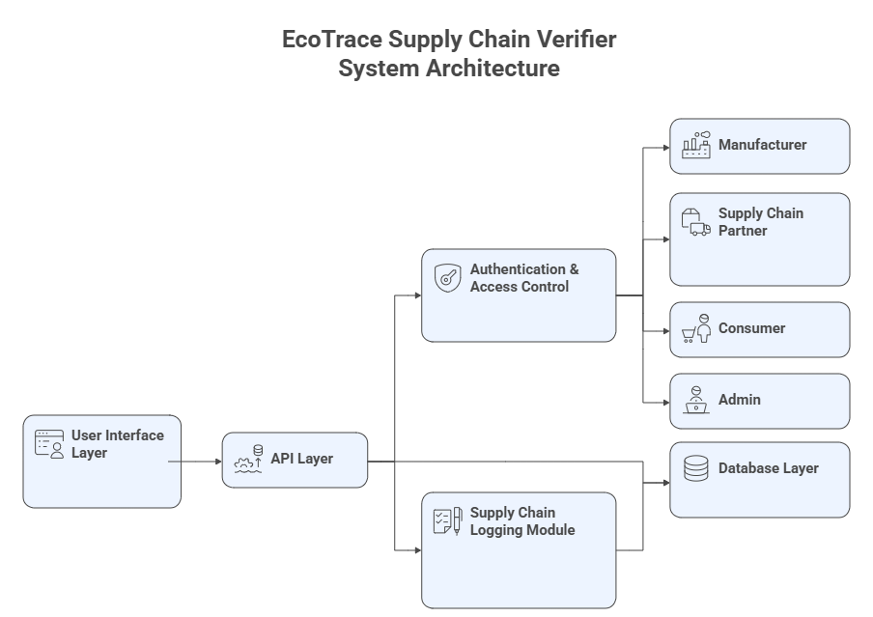
- verification status
Data Flow
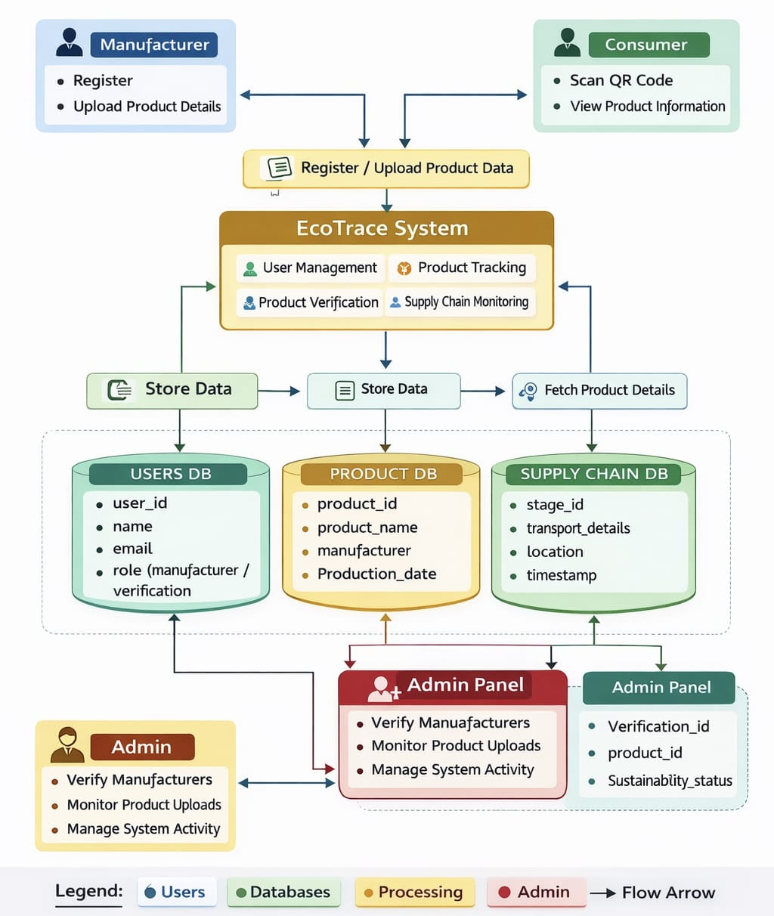

The Data Flow Diagram (DFD) of the EcoTrace Supply Chain Verifier System explains how information flows between users, the system, and the databases.
1. Manufacturer
- The Manufacturer first registers in the system.
- After registration, they upload product details such as product name, manufacturing date, and other supply chain information.
- This data is sent to the EcoTrace System for processing.
2. Consumer
- The Consumer interacts with the system by scanning the QR code on the product.
- After scanning, the consumer can view the product information, including manufacturing details and supply chain journey.

3. Register / Upload Product Data
- This step acts as an input stage where product details from manufacturers are collected and submitted to the EcoTrace System.
4. EcoTrace System: The EcoTrace System is the main processing unit. It performs several functions:
- User Management – manages user accounts such as manufacturers and admins.
- Product Tracking – tracks product move

API Structure
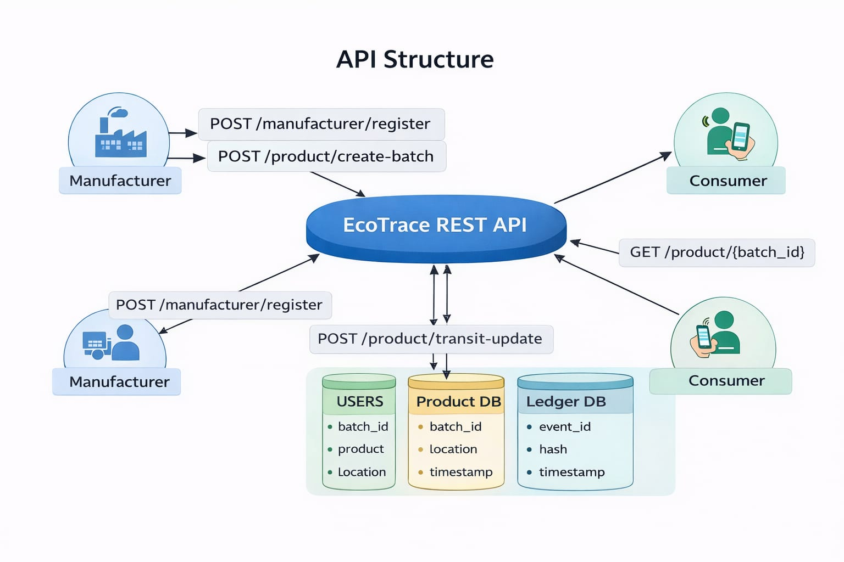

The API Structure represents how different system components communicate with each other using REST APIs in the EcoTrace system. The API acts as the central communication layer between manufacturers, consumers, and the system databases. It ensures that product information is securely created, updated, stored, and retrieved.
At the centre of the architecture is the EcoTrace REST API, which handles all requests coming from external users such as manufacturers and consumers. The API processes these requests and interacts with the system databases to store or retrieve the required information.

Manufacturer Interaction with the API
Manufacturers use the API to register themselves and create product batches. This allows the system to track the origin and movement of products.
In this process, a manufacturer sends their registration details to the EcoTrace REST API. The API validates the information and stops.

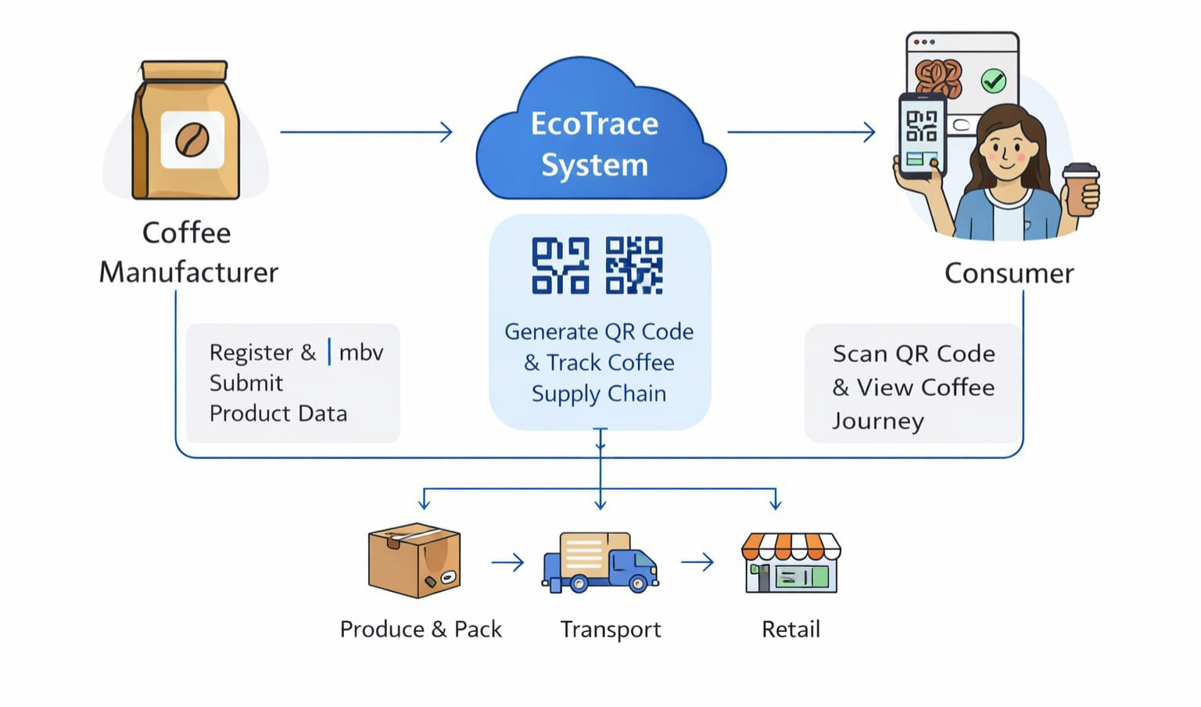
EcoTrace Supply Chain Verifier (Coffee Example)

This diagram shows the simplified data flow of the EcoTrace Supply Chain Verifier system using coffee as the product example.
Coffee Manufacturer: The manufacturer registers in the EcoTrace system and submits product details such as coffee batch information.
EcoTrace System: The system processes the product information and generates a unique Batch ID and QR code for the coffee product. This QR code is used to track the product across the supply chain.
Supply Chain Tracking: The coffee product moves through different stages of the supply chain:
Produce & Pack, Transport, Retail
At each stage, the system records the product status and updates the supply chain log.
Consumer Verification: The consumer scans the QR code on the coffee product using a mobile device. The EcoTrace system retrieves the stored data and displays the complete journey of the product, ensuring transparency and authenticity.
This data flow ensures that every step of the coffee product’s journey is recorded and can be verified by consumers.

Flow Chart
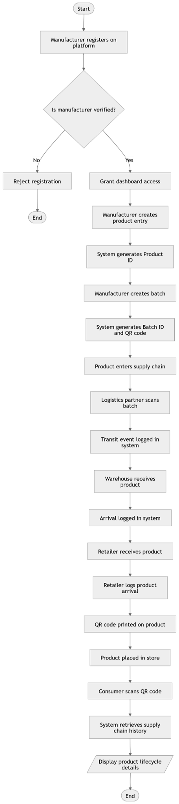
Full Flow Flowchart
The first flowchart demonstrates the end-to-end process. This provides a macro-level overview of the entire supply chain lifecycle, combining the individual processes from registration and production to logistics and the final consumer query.
- The Flow:
  - Onboarding: A manufacturer registers on the platform. If not verified, they are rejected. If verified, they are granted dashboard access.
  - Production: The manufacturer creates a product entry (System generates Product ID), then creates a specific batch (System generates Batch ID and QR code).
  - Transit: The product enters the supply chain. Logistics partners scan the batch, logging transit events. Warehouses receive the product and log its arrival.
  - Retail: The retailer receives the product and logs its arrival. The QR code is printed/placed on the product, and it is put on store shelves.
  - Consumer Verification: A consumer scans the QR code. The system retrieves the full supply chain history and displays the product lifecycle details, ending the process.

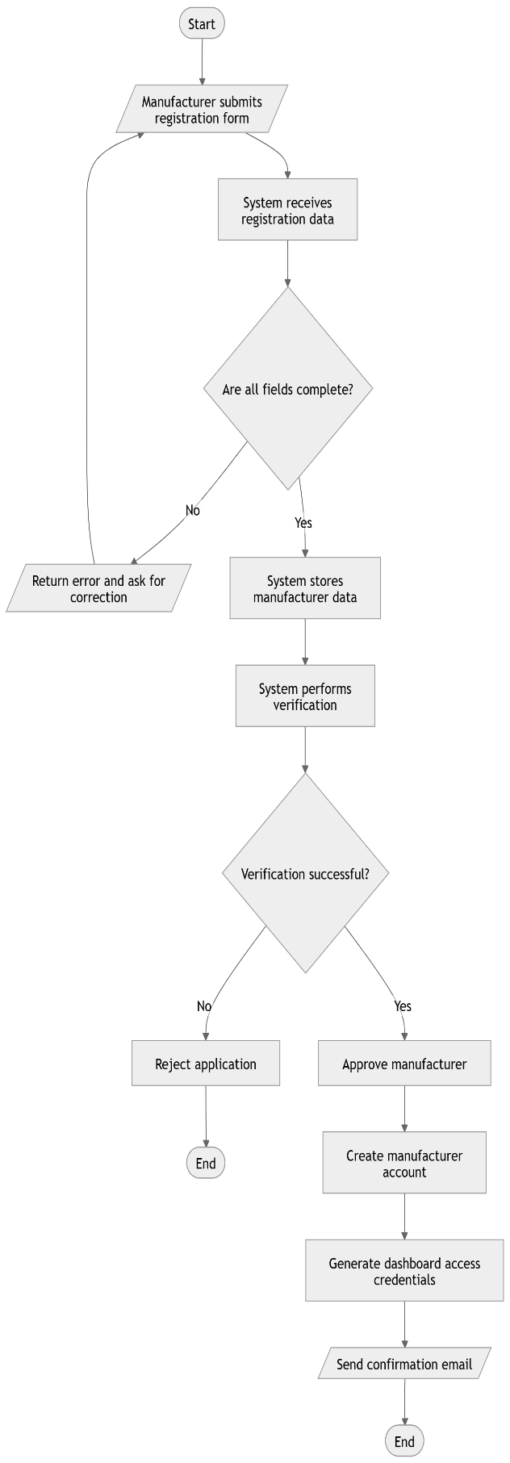
Manufacturer Registration Flowchart
It is an onboarding and verification flow diagram. It shows how a new manufacturer applies to join the platform and the automated steps the system takes to verify and approve them.
- The Flow:
- Start: The manufacturer submits a registration form.

- Initial Check: The system receives the data and checks if all required fields are complete.

- Decision (Are all fields complete?):
    - No: An error is returned, looping the manufacturer back to correct the form.
    - Yes: The system stores the data and performs a verification check (e.g., checking licenses or credentials).

- Decision (Verification successful?):
    - No: The application is rejected, and the process ends.
    - Yes: The manufacturer is approved. The system creates their account, generates dashboard access credentials, sends a confirmation email, and the process ends.

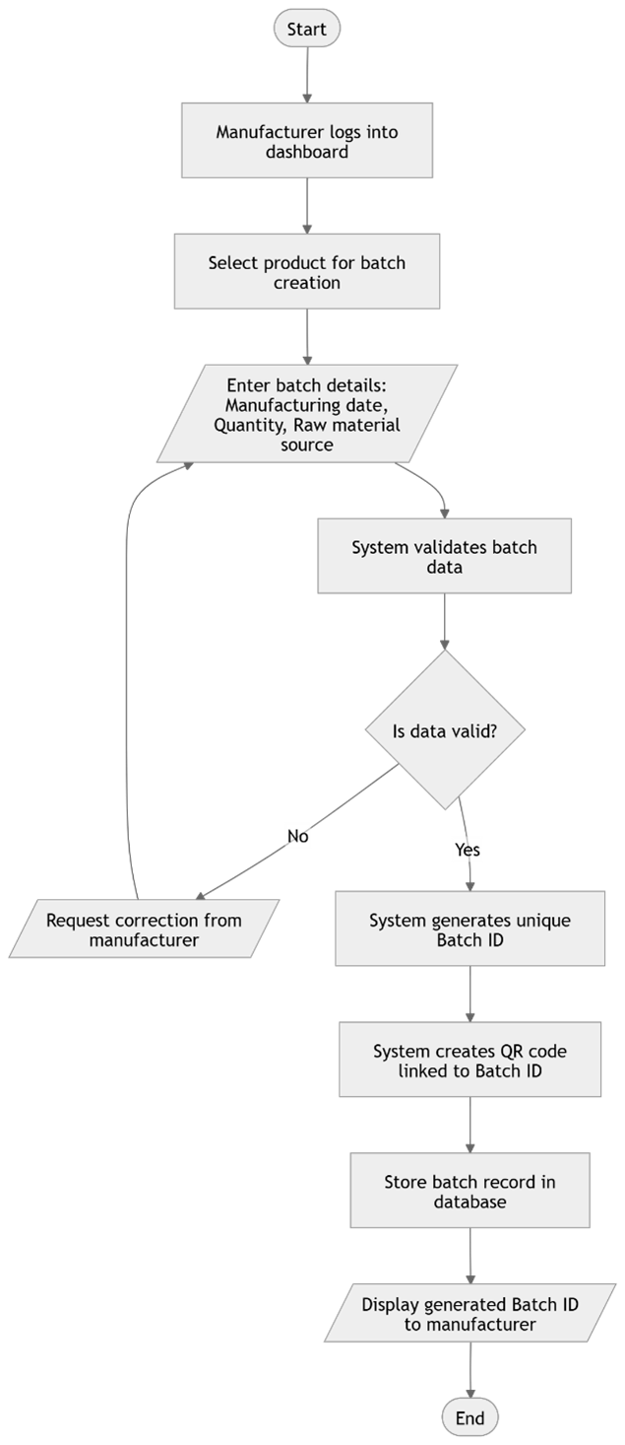
Batch Number Production Flowchart
It is a data entry and generation flowchart for manufacturers. It outlines the steps a verified manufacturer takes to create a new batch of products in the system, resulting in a secure, trackable QR code.
The Flow:
- Start: The manufacturer logs into their dashboard and selects a product to create a batch for.
- Input: The manufacturer enters batch details (Manufacturing date, Quantity, Raw material source).
- Validation: The system validates this data.
  - Decision (Is data valid?):
    - No: The system requests a correction, looping the manufacturer back to the input step.
    - Yes: The system generates a unique Batch ID and a corresponding QR code.
  - Completion: The batch record is stored in the database, the generated Batch ID is displayed to the manufacturer, and the process ends.

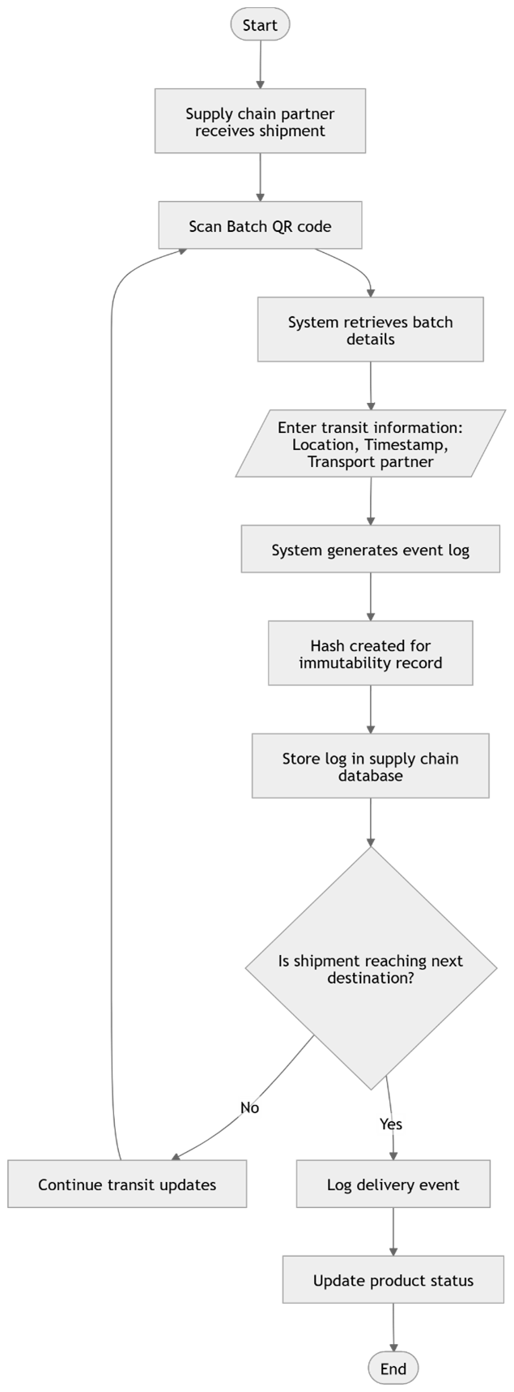
Supply Chain Update Flowchart
It is a logistical tracking flow diagram. It details how supply chain partners (like transporters or warehouses) log transit events to maintain a continuous, immutable record of the product's journey.
- The Flow:
  - Start: A supply chain partner receives a shipment and scans the Batch QR code.
  - Data Entry: The system retrieves the batch details. The partner enters transit information (Location, Timestamp, Transport partner).
  - Record Creation: The system generates an event log and creates a cryptographic hash of this log to ensure immutability. This log is then stored in the supply chain database.
  - Decision (Is shipment reaching next destination?):
    - No: If it's an intermediate stop, the status remains "Continue transit updates," and the loop resets for the next partner to scan the QR code later.
    - Yes: If it has reached its final destination (like a retailer), a delivery event is logged, the product status is updated to reflect its arrival, and the process ends.

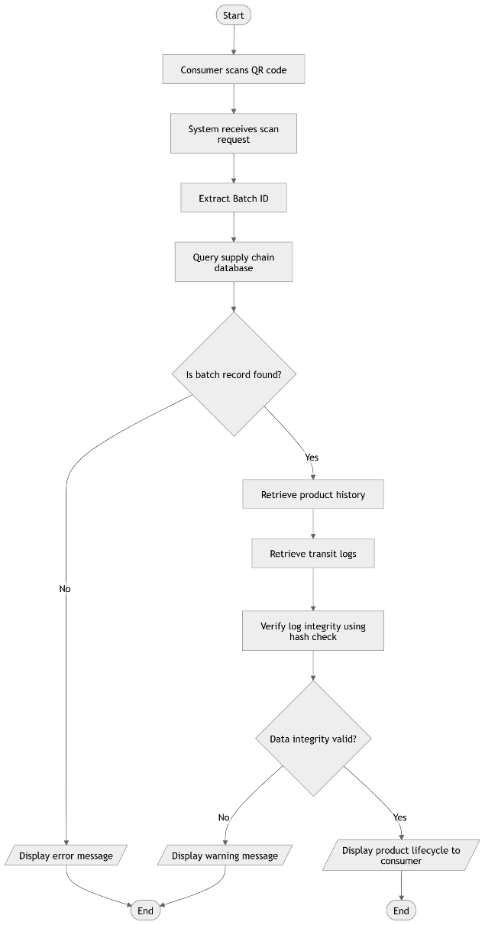
Consumer Query Flowchart
It is a process flow diagram showing the end-user (consumer) experience. It explains how a consumer uses the system to verify the authenticity and history of a product by scanning its QR code, including the system's background integrity checks.
- The Flow:
  - Start: The consumer scans the QR code on the product.
  - Processing: The system receives the scan request and extracts the unique Batch ID. It then queries the supply chain database.
  - Decision (Is batch record found?):
    - No: The system displays an error message, and the process ends.
    - Yes: The system retrieves the product's history and transit logs.
  - Verification: The system verifies the integrity of the logs using a cryptographic hash check.
5. Decision (Data integrity valid?):
No: If the hashes do not match, the system displays warning message to the customer and the process end.
Yes: If the data is secure, the system displays the full verified product lifecycle to the consumer and the process ends.

UI Design

Initial Screens: The UI design begins with a clean and minimal Splash Screen displaying the EcoTrace logo. This establishes brand identity and provides a professional entry point into the application. The splash screen transitions automatically to the authentication interface.

The Login Screen is designed with simplicity and clarity. It includes fields for email and password along with validation prompts. If the user already has an account, they can directly log in using credentials. Error messages are displayed for invalid inputs, ensuring proper validation and secure authentication.

If the user does not have an account, they are redirected to the Sign-Up Screen. Here, the user fills basic details such as name, email, password, location, and selects their role (Manufacturer or Supply Chain Partner). After successful registration, the user is redirected back to the login screen for authentication.

Upon login, the system verifies the role and automatically loads the respective dashboard. This role-based redirection ensures secure access control and personalized user experience.
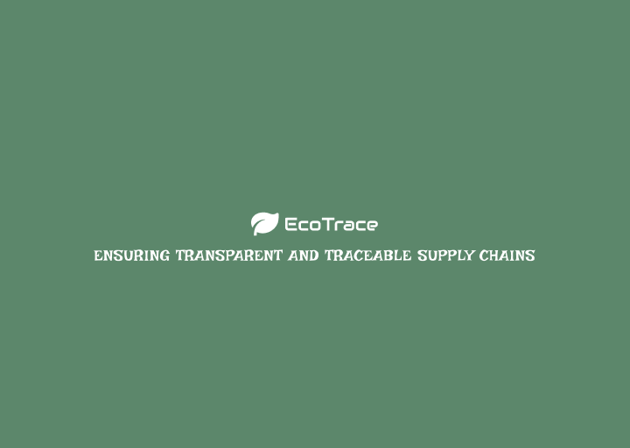
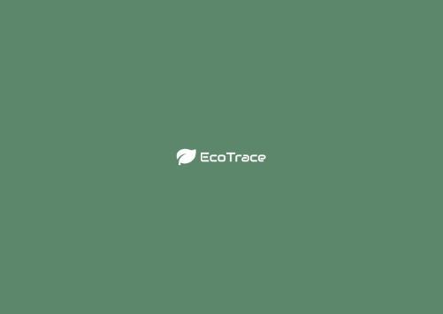

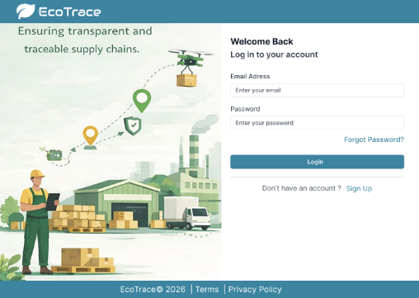
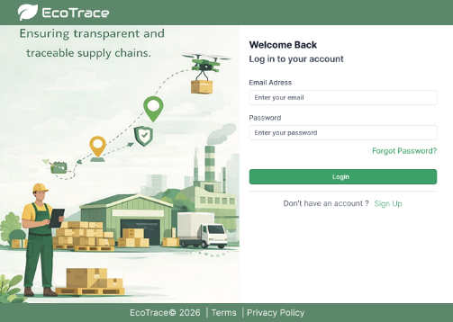
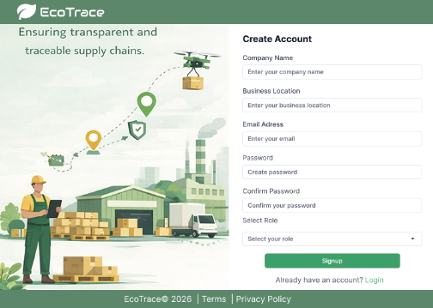

Manufacturer Dashboard

The Manufacturer Dashboard serves as the central control panel for manufacturers to manage products, create batches, and monitor supply chain progress. The interface is organized with a left-side navigation menu containing options such as Dashboard, Add Product, Supply Chain, and Batch Tracking, along with profile and logout options. At the top of the dashboard, summary cards provide a quick overview of system activity, including Total Products, Active Batches, In Transit shipments, and Completed Supply Chains. Below this section, a Recent Batches table displays detailed information such as Batch ID, Product Name, Current Stage, Status, Last Updated time, and action options. This layout allows manufacturers to quickly monitor product batches and track the current stage of each supply chain process.

Add Product Screen

The Add Product screen allows manufacturers to create and register a new product batch in the system. The interface is designed using a structured form layout divided into multiple sections for clarity and data organization. The Product Information section includes fields such as Product Name, Product Category, and Description. The Batch Details section captures batch-related data including Batch ID, Batch Quantity, Unit of Measurement, and Expiry Date. Additionally, the Origin Information section records details about the product source, such as Origin Location, Manufacturer Name, and Certification Type to ensure transparency and sustainability verification. A Supply Chain Initialization section allows the manufacturer to define the first stage of the supply chain, specify the next destination, and upload supporting certification documents. Once the information is completed, the manufacturer can save the batch and generate a QR code that will later be used for product tracking.

Supply Chain Screen

The Supply Chain screen manages the assignment of supply chain partners and the activation of tracking for a specific batch. The interface begins with a Batch Information panel displaying details such as Batch ID, Product Name, Production Date, and Quantity. Manufacturers can then assign a Supply Chain Partner by entering information including the partner company name, contact person, phone number, dispatch date, origin location, destination, transport type, vehicle number, and expected delivery date. A tracking panel on the right displays the current shipment status, while a Supply Chain Timeline visually represents key stages of the product journey, such as processing completion, readiness for dispatch, and transit stages. After entering the required details, the manufacturer can activate tracking, enabling continuous monitoring of the product movement.

Batch Tracking Screen

The Batch Tracking screen provides a comprehensive overview of all product batches and their current supply chain status. The interface includes filtering options that allow users to categorize batches based on stages such as All, Processing, In Transit, Storage, and Sale. A table displays information including Batch ID, Product Name, Quantity, Status, and the last updated location or facility. This helps manufacturers quickly identify where each batch is in the supply chain. Additional batch details are displayed below the table, including production date and total quantity. The screen also provides an option to Assign New Partner, allowing manufacturers to update logistics partners if required. This module ensures that all product batches can be easily monitored and traced throughout the entire supply chain lifecycle.
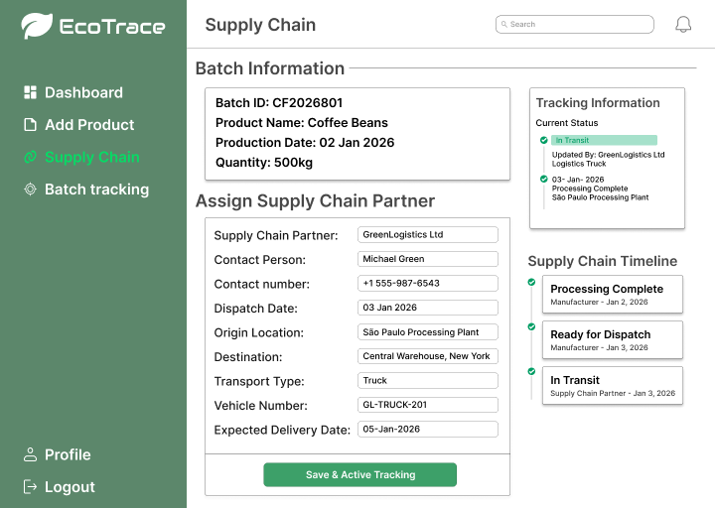
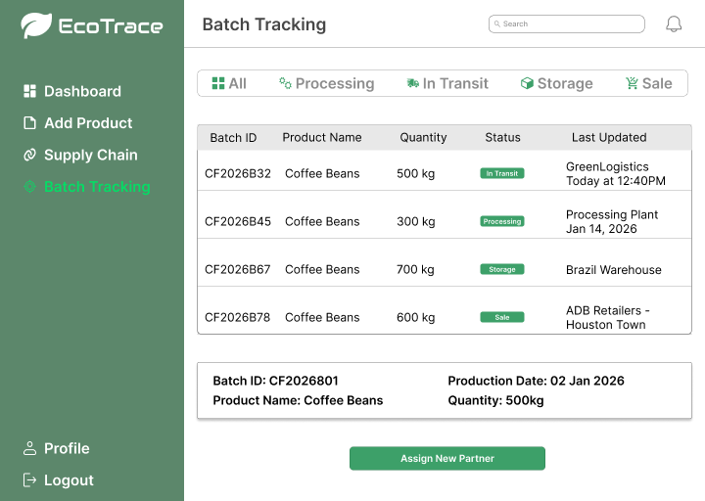
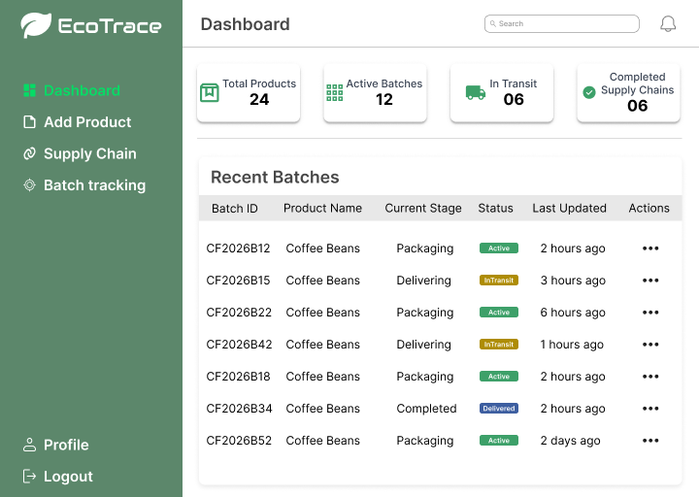
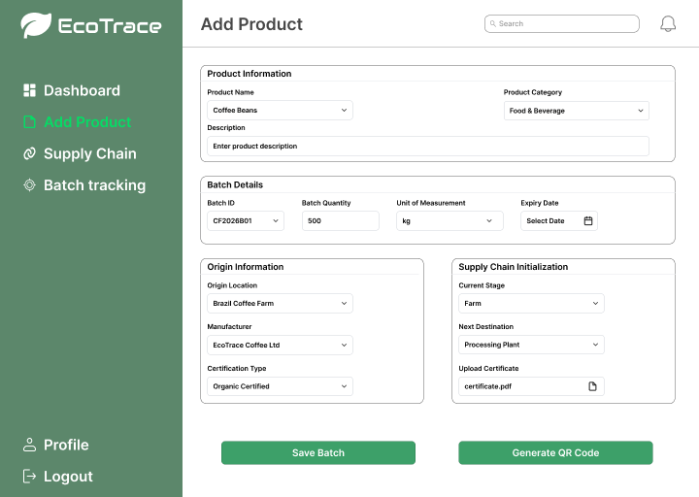

Supply Chain Partner Dashboard

The Supply Chain Partner Dashboard provides logistics partners with a centralized interface to monitor and manage the movement of product batches within the supply chain. The dashboard displays key operational information such as batches updated today, batches currently in transit, and the most recently updated batch, including its batch ID and status. These summary sections allow supply chain partners to quickly understand the current logistics activity and identify batches that require attention.
In addition to the overview information, the dashboard includes Quick Action tools that improve operational efficiency. Users can quickly scan a QR code or manually enter a batch ID to access detailed batch information and update shipment stages. This functionality ensures that supply chain partners can immediately locate a product batch in the system and record new updates as it moves through different logistics stages.

Update Supply Chain Screen

The Update Supply Chain screen allows supply chain partners to record and manage the movement of a product batch as it progresses through different stages of the supply chain. At the top of the interface, a Batch Details section displays important information such as the product name, batch ID, manufacturer name, origin location, production date, and the current stage of the product. This information provides context to the logistics partner before making any updates.
Below the batch details, the Update Supply Chain Stage section enables the partner to log a new stage of the product journey. Here, users can enter the batch ID, stage location, and updated stage status to reflect the current movement of the product. The system also includes an Active Tracking section, which visually represents the product’s journey through a supply chain timeline. This timeline shows the different stages that the product has passed through and highlights the current stage where the batch is located. By providing both update and tracking features in a single interface, the system ensures accurate recording and real-time monitoring of product movement throughout the supply chain.
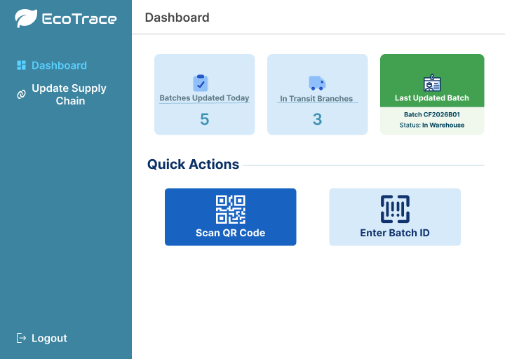
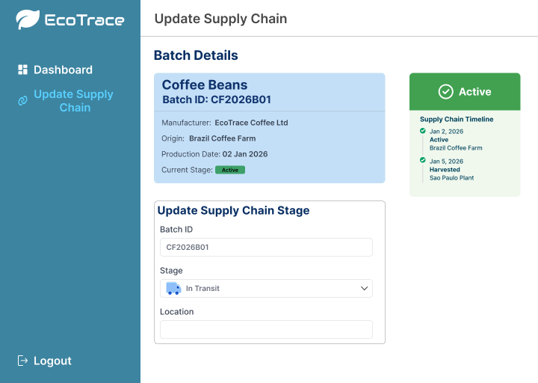

Consumer Screens

The consumer interface of the EcoTrace system allows customers to easily access transparent information about a product by scanning the QR code printed on its packaging. These screens are designed to provide a clear and simple view of the product’s origin, journey, and sustainability practices, helping consumers understand how the product was produced and delivered. The consumer side focuses on providing reliable information that builds trust and supports responsible purchasing decisions.
The first screen is the Product Information Screen, which displays the basic details of the product. This includes information such as the batch ID, product name, origin location, production date, quantity or weight, and an image of the product. This screen helps consumers quickly identify the product they are viewing and understand where it was produced.
The second screen is the Product Journey Screen, which shows the complete supply chain timeline of the product. It presents different stages such as harvesting, processing, and transportation along with the corresponding locations and dates.
The final screen is the Sustainability Details Screen, which highlights the ethical and environmental practices followed during production. This may include certifications such as fair trade, organic farming practices, ethical sourcing, and environmentally friendly cultivation methods.
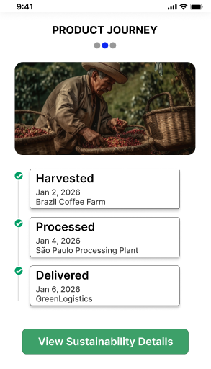
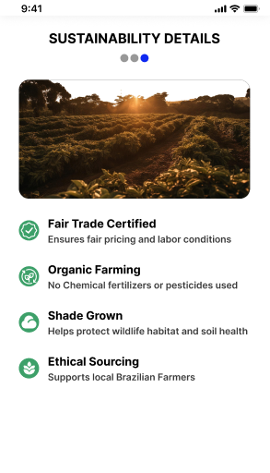
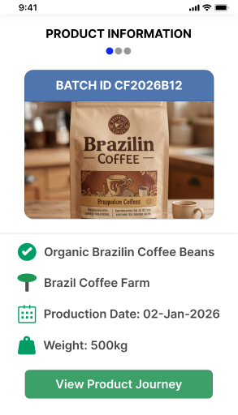
Impact on SDG 12 - Responsible Consumption and Production

The EcoTrace Supply Chain Verifier contributes to Sustainable Development Goal 12 Responsible Consumption and Production by promoting transparency and accountability in product supply chains. One of the major challenges in responsible consumption is the lack of accessible information about how products are sourced, manufactured, and transported. EcoTrace addresses this issue by allowing manufacturers and supply chain partners to log each stage of a product’s journey in a structured digital system. By creating a traceable record of production and logistics activities, the platform helps ensure that information about a product’s origin and lifecycle is reliable and easily accessible.

The platform empowers consumers to make informed purchasing decisions by providing visibility into the environmental and ethical aspects of the products they buy. Through QR code or batch number scanning, consumers can view the complete lifecycle of a product, including details about manufacturing processes, sourcing, and transportation stages. This level of transparency encourages consumers to choose products that follow responsible production practices and discourages companies from engaging in unsustainable or unethical supply chain activities.

Additionally, EcoTrace encourages manufacturers and supply chain partners to adopt more sustainable and responsible production practices. Since every stage of the supply chain is documented and visible, organizations are motivated to maintain ethical sourcing, reduce waste, and follow environmentally conscious processes. By increasing accountability across the supply chain and empowering consumers with verified information, EcoTrace supports the global effort to promote sustainable production systems and responsible consumption patterns.

